**Module–4(Automation Core Testing)**

* **Load Runner Up**

**Q. Which components have you used in Load Runner ?**

Ans : There are 3 components used in load runner :

VuGen (Virtual User Generator), Controller, Analysis

**Q. How can you set the number of Vusers in Load Runner ?**

Ans : You can set the number of Vusers in the controller section while creating your scenarios.

**Q. What is Correlation ?**

Ans : Correlation is the process of capturing and storing the dynamic response from the server and passing it on to subsequent requests.

**Q. What is the process for developing a Vuser Script ?**

Ans : There are 5 steps for developing a Vuser script :

* Recording the Vuser script.
* Edit the Vuser script.
* Runtime setting.
* Run the Vuser script in stand-alone mode.
* Incorporate the Vuser script into a load runner scenario.

**Q. How Load Runner interacts with the application ?**

Ans : Load runner simulates user activity by generating messages between application components or by simulating interactions with the user interface such as key presses or mouse movements. The messages and interactions to be generated are stored in scripts.

**Q. How many VUsers are required for load testing ?**

Ans : Number of concurrent users that an application can support and scalability to allow more users to access it.

**Q. What is the relationship between Response Time and Throughput ?**

Ans : The response time for an average transaction tends to decrease as you increase overall throughput.

**Q. What is the difference between hits/second and requests/second ?**

Ans : Hit/second : Hits per second means the number of hits the server receives in one second from the Vuser.

Requests/second : Request per second is the number of request the Vuser will request from the server.

* **Selenium IDE**

**Q. What is Automation Testing ?**

Ans : Automation testing is the use of software to control the execution of tests, the comparison of actual outcomes to predicted outcomes, the setting up of test preconditions, and other test control and test reporting functions, In other word automation testing is a process of writing a computer program to do testing that would otherwise need to be done manually.

**Q. Which Are The Browsers Supported By Selenium Ide ?**

Ans : Google chrome, Mozilla firefox, and Microsoft edge.

**Q. What are the benefits of Automation Testing ?**

Ans : 70% faster than the manual testing.

* Wider test coverage of application features.
* Reliable in results.
* Ensure consistency.
* Saves time and cost.
* Improves accuracy.
* Human intervention is not required while execution.
* Increases efficiency.
* Better speed in executing tests.
* Re-usable test scripts.
* Test frequently and thoroughly.
* More cycle of execution can be achieved through automation.
* Early time to market.

**Q. What are the advantages of Selenium ?**

Ans : It’s open source, free to use, and free of charge.

* Highly extensible.
* Can run tests across different browsers.
* Supports various operating systems.
* Support mobile devices.
* Can execute tests while the browser is minimized .
* Can execute tests in parallel.

**Q. Why testers should opt for Selenium and not QTP ?**

Ans : QTP test scripts run only on the windows environment, they cannot be run across all browsers. while selenium supports a wide range of programming languages, selenium is OS independent and allows test scripts to run across all browsers.

**Q. To validate the tops technologies website Contact us page and enter your friend detail at last “login and side menu”**

https://www.tops-int.com/contact-us/ 

Ans : **ERROR**

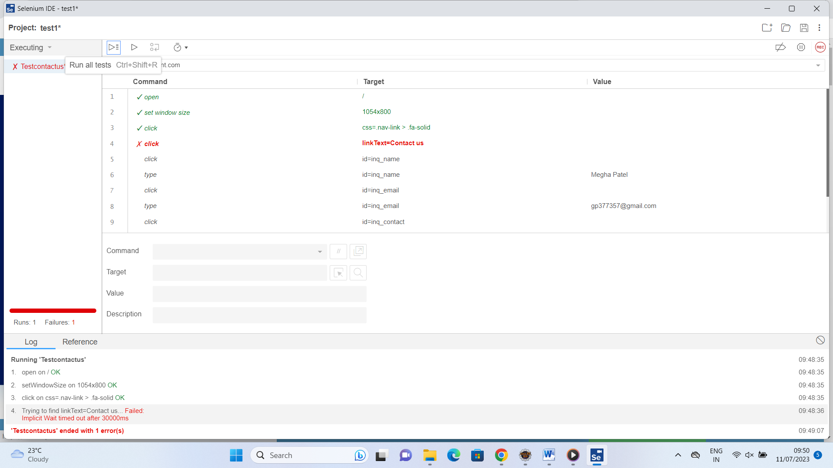

**RUN**

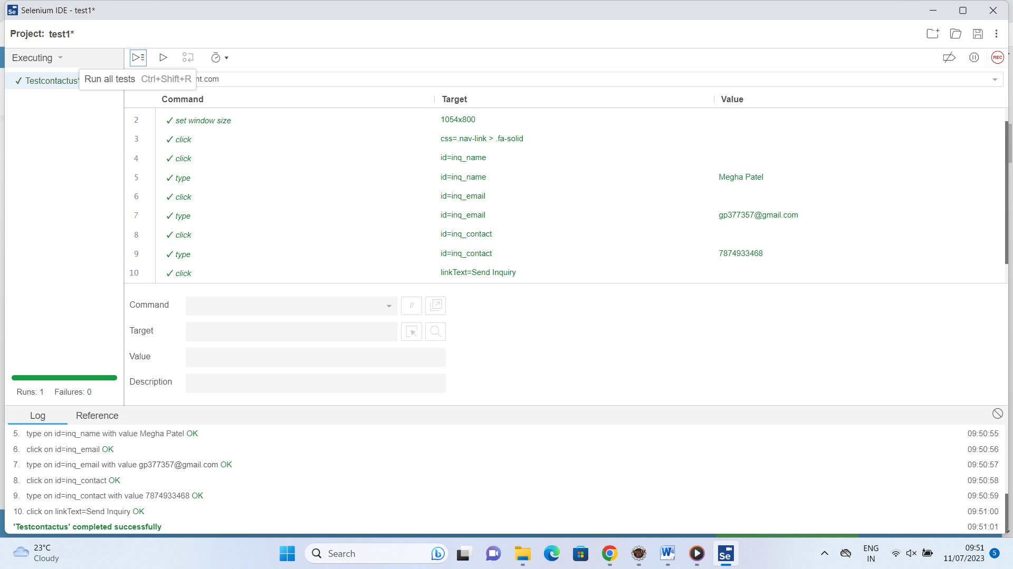

**SCRIPT**

{ "id": "55aed9a2-ec36-480d-97a5-e2f963a6656f",

"version": "2.0",

"name": "test1",

"url": "https://www.tops-int.com",

"tests": [{

"id": "540610b7-1a17-4866-9cca-8e3b6e04364f",

"name": "Testcontactus",

"commands": [{

"id": "57a07309-ebe8-4852-8b80-6bc2dd90bab6",

"comment": "",

"command": "open",

"target": "/",

"targets": [],

"value": ""

}, {

"id": "50b4a1f8-f63c-49b4-9493-0bed85c24322",

"comment": "",

"command": "setWindowSize",

"target": "1054x800",

"targets": [],

"value": ""

}, {

"id": "5b01270c-384c-486b-97d6-2c1c082d4251",

"comment": "",

"command": "click",

"target": "css=.nav-link > .fa-solid",

"targets": [

["css=.nav-link > .fa-solid", "css:finder"],

["xpath=//div[@id='navbarNav']/ul/li[6]/a/i", "xpath:idRelative"],

["xpath=//a/i", "xpath:position"]

],

"value": ""

}, {

"id": "8ca9a503-bb95-44bd-a5e3-68fbc85f3a3b",

"comment": "",

"command": "click",

"target": "id=inq_name",

"targets": [

["id=inq_name", "id"],

["name=name", "name"],

["css=.px-3 > div #inq_name", "css:finder"],

["xpath=//input[@id='inq_name']", "xpath:attributes"],

["xpath=//div[@id='course-page']/section[2]/div/div/div[2]/div/div[2]/div/div/form/input", "xpath:idRelative"],

["xpath=//input", "xpath:position"]

],

"value": ""

}, {

"id": "86ed0afb-5026-4b9a-a51a-b3c4922aa89a",

"comment": "",

"command": "type",

"target": "id=inq_name",

"targets": [

["id=inq_name", "id"],

["name=name", "name"],

["css=.px-3 > div #inq_name", "css:finder"],

["xpath=//input[@id='inq_name']", "xpath:attributes"],

["xpath=//div[@id='course-page']/section[2]/div/div/div[2]/div/div[2]/div/div/form/input", "xpath:idRelative"],

["xpath=//input", "xpath:position"]

],

"value": "Megha Patel"

}, {

"id": "c76539b5-dcf3-49cd-bdbc-089823662fba",

"comment": "",

"command": "click",

"target": "id=inq_email",

"targets": [

["id=inq_email", "id"],

["name=email", "name"],

["css=.px-3 > div #inq_email", "css:finder"],

["xpath=//input[@id='inq_email']", "xpath:attributes"],

["xpath=//div[@id='course-page']/section[2]/div/div/div[2]/div/div[2]/div/div/form/input[2]", "xpath:idRelative"],

["xpath=//input[2]", "xpath:position"]

],

"value": ""

}, {

"id": "85955e6f-0ebb-4aad-98b9-bcac4f998f26",

"comment": "",

"command": "type",

"target": "id=inq_email",

"targets": [

["id=inq_email", "id"],

["name=email", "name"],

["css=.px-3 > div #inq_email", "css:finder"],

["xpath=//input[@id='inq_email']", "xpath:attributes"],

["xpath=//div[@id='course-page']/section[2]/div/div/div[2]/div/div[2]/div/div/form/input[2]", "xpath:idRelative"],

["xpath=//input[2]", "xpath:position"]

],

"value": "gp377357@gmail.com"

}, {

"id": "a7e99700-7c18-4fce-bb44-fdb670c9159d",

"comment": "",

"command": "click",

"target": "id=inq_contact",

"targets": [

["id=inq_contact", "id"],

["name=contact", "name"],

["css=.px-3 > div #inq_contact", "css:finder"],

["xpath=//input[@id='inq_contact']", "xpath:attributes"],

["xpath=//div[@id='course-page']/section[2]/div/div/div[2]/div/div[2]/div/div/form/div[2]/input", "xpath:idRelative"],

["xpath=//div[2]/input", "xpath:position"]

],

"value": ""

}, {

"id": "b441ed65-d631-4f0c-92c3-c35a6718fb40",

"comment": "",

"command": "type",

"target": "id=inq_contact",

"targets": [

["id=inq_contact", "id"],

["name=contact", "name"],

["css=.px-3 > div #inq_contact", "css:finder"],

["xpath=//input[@id='inq_contact']", "xpath:attributes"],

["xpath=//div[@id='course-page']/section[2]/div/div/div[2]/div/div[2]/div/div/form/div[2]/input", "xpath:idRelative"],

["xpath=//div[2]/input", "xpath:position"]

],

"value": "7874933468"

}, {

"id": "a91cb14c-2a89-4829-a44b-418061334c06",

"comment": "",

"command": "click",

"target": "linkText=Send Inquiry",

"targets": [

["linkText=Send Inquiry", "linkText"],

["css=.px-3 > div .btn", "css:finder"],

["xpath=//a[contains(text(),'Send Inquiry')]", "xpath:link"],

["xpath=//a[@type='button']", "xpath:attributes"],

["xpath=//div[@id='course-page']/section[2]/div/div/div[2]/div/div[2]/div/div/form/div[3]/a", "xpath:idRelative"],

["xpath=(//a[contains(@href, 'javascript:;')])[158]", "xpath:href"],

["xpath=//div[3]/a", "xpath:position"],

["xpath=//a[contains(.,'Send Inquiry')]", "xpath:innerText"]

],

"value": ""

}]

}],

"suites": [{

"id": "b963c9c9-01f5-4897-8aab-0ef7672d0868",

"name": "Default Suite",

"persistSession": false,

"parallel": false,

"timeout": 300,

"tests": ["540610b7-1a17-4866-9cca-8e3b6e04364f"]

}],

"urls": ["https://www.tops-int.com/"],

"plugins": []

}